**MAKALAH BIOSTATISTIK**

**KORELASI**



**D**

**I**

**S**

**U**

**S**

**U**

**N**

**OLEH:**

Nama Kelompok

Anggota:

1. Aprilliyanti Nurjannah Hrp (201101148)
2. Berlian Prasidwi (201101066)
3. Atika Amalia Butar-Butar (201101008)
4. Christie Yolanda (201101148)
5. Cici Nadya (201101176)

**FAKULTAS KEPERAWATAN**

**UNIVERSITAS SUMATERA UTARA**

**TA 2022/2023**

**Frequencies**

|  |  |  |
| --- | --- | --- |
| **Notes** | | |
| Output Created | | 23-NOV-2022 10:24:29 |
| Comments | |  |
| Input | Data | D:\OUTPUT DATA BB&LP.sav |
| Active Dataset | DataSet1 |
| Filter | <none> |
| Weight | <none> |
| Split File | <none> |
| N of Rows in Working Data File | 49 |
| Missing Value Handling | Definition of Missing | User-defined missing values are treated as missing. |
| Cases Used | Statistics are based on all cases with valid data. |
| Syntax | | FREQUENCIES VARIABLES=BB  /HISTOGRAM  /ORDER=ANALYSIS. |
| Resources | Processor Time | 00:00:03,16 |
| Elapsed Time | 00:00:03,71 |

[DataSet1] D:\OUTPUT DATA BB&LP.sav

|  |  |  |
| --- | --- | --- |
| **Statistics** | | |
| Berat Badan | | |
| N | Valid | 49 |
| Missing | 0 |

|  |  |  |  |  |  |
| --- | --- | --- | --- | --- | --- |
| **Berat Badan** | | | | | |
|  | | Frequency | Percent | Valid Percent | Cumulative Percent |
| Valid | 39 | 1 | 2.0 | 2.0 | 2.0 |
| 42 | 3 | 6.1 | 6.1 | 8.2 |
| 43 | 1 | 2.0 | 2.0 | 10.2 |
| 45 | 3 | 6.1 | 6.1 | 16.3 |
| 46 | 2 | 4.1 | 4.1 | 20.4 |
| 47 | 1 | 2.0 | 2.0 | 22.4 |
| 48 | 3 | 6.1 | 6.1 | 28.6 |
| 49 | 2 | 4.1 | 4.1 | 32.7 |
| 50 | 4 | 8.2 | 8.2 | 40.8 |
| 52 | 1 | 2.0 | 2.0 | 42.9 |
| 54 | 6 | 12.2 | 12.2 | 55.1 |
| 55 | 4 | 8.2 | 8.2 | 63.3 |
| 56 | 2 | 4.1 | 4.1 | 67.3 |
| 57 | 2 | 4.1 | 4.1 | 71.4 |
| 58 | 1 | 2.0 | 2.0 | 73.5 |
| 59 | 1 | 2.0 | 2.0 | 75.5 |
| 60 | 1 | 2.0 | 2.0 | 77.6 |
| 63 | 1 | 2.0 | 2.0 | 79.6 |
| 65 | 3 | 6.1 | 6.1 | 85.7 |
| 70 | 2 | 4.1 | 4.1 | 89.8 |
| 71 | 1 | 2.0 | 2.0 | 91.8 |
| 77 | 1 | 2.0 | 2.0 | 93.9 |
| 80 | 2 | 4.1 | 4.1 | 98.0 |
| 85 | 1 | 2.0 | 2.0 | 100.0 |
| Total | 49 | 100.0 | 100.0 |  |

GRAPH

/HISTOGRAM(NORMAL)=BB.

**Graph**

|  |  |  |
| --- | --- | --- |
| **Notes** | | |
| Output Created | | 23-NOV-2022 11:16:04 |
| Comments | |  |
| Input | Data | D:\OUTPUT DATA BB&LP.sav |
| Active Dataset | DataSet1 |
| Filter | <none> |
| Weight | <none> |
| Split File | <none> |
| N of Rows in Working Data File | 49 |
| Syntax | | GRAPH  /HISTOGRAM(NORMAL)=BB. |
| Resources | Processor Time | 00:00:01,06 |
| Elapsed Time | 00:00:00,54 |

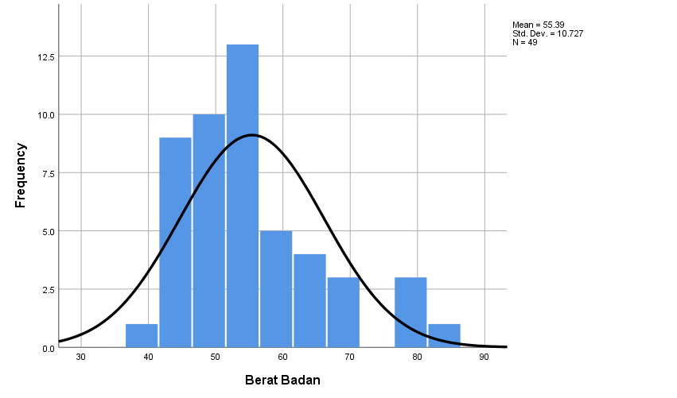

Dari hasil grafik diatas dapat kita lihat bahwa hasil kurva normal dan menenai seluruh diagram batang sehingga dapat disimpulkan untuk grafik histogram berat badan yaitu distribusi penyebaran normal.

**Graph**

|  |  |  |
| --- | --- | --- |
| **Notes** | | |
| Output Created | | 23-NOV-2022 11:20:31 |
| Comments | |  |
| Input | Data | D:\OUTPUT DATA BB & LP.sav |
| Active Dataset | DataSet1 |
| Filter | <none> |
| Weight | <none> |
| Split File | <none> |
| N of Rows in Working Data File | 49 |
| Syntax | | GRAPH  /HISTOGRAM(NORMAL)=LP. |
| Resources | Processor Time | 00:00:00,44 |
| Elapsed Time | 00:00:00,38 |

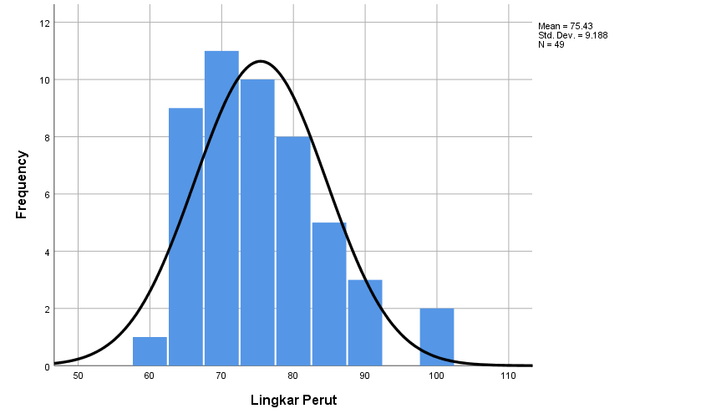

Dari hasil grafik diatas dapat kita lihat bahwa hasil kurva normal dan menenai seluruh diagram batang sehingga dapat disimpulkan untuk grafik histogram lingkar perut yaitu distribusi penyebaran normal.

**NPar Tests**

|  |  |  |
| --- | --- | --- |
| **Notes** | | |
| Output Created | | 23-NOV-2022 11:22:35 |
| Comments | |  |
| Input | Data | D:\OUTPUT DATA BB & LP.sav |
| Active Dataset | DataSet1 |
| Filter | <none> |
| Weight | <none> |
| Split File | <none> |
| N of Rows in Working Data File | 49 |
| Missing Value Handling | Definition of Missing | User-defined missing values are treated as missing. |
| Cases Used | Statistics for each test are based on all cases with valid data for the variable(s) used in that test. |
| Syntax | | NPAR TESTS  /K-S(NORMAL)=BB LP  /MISSING ANALYSIS. |
| Resources | Processor Time | 00:00:00,03 |
| Elapsed Time | 00:00:00,10 |
| Number of Cases Alloweda | 629145 |

|  |
| --- |
| a. Based on availability of workspace memory. |

|  |  |  |  |
| --- | --- | --- | --- |
| **One-Sample Kolmogorov-Smirnov Test** | | | |
|  | | Berat Badan | Lingkar Perut |
| N | | 49 | 49 |
| Normal Parametersa,b | Mean | 55.39 | 75.43 |
| Std. Deviation | 10.727 | 9.188 |
| Most Extreme Differences | Absolute | .155 | .110 |
| Positive | .155 | .110 |
| Negative | -.086 | -.068 |
| Test Statistic | | .155 | .110 |
| Asymp. Sig. (2-tailed) | | .005c | .183c |

|  |
| --- |
| a. Test distribution is Normal. |
| b. Calculated from data. |
| c. Lilliefors Significance Correction. |

Dikarenakanpada gambar diatas p valuenya 2-tailed, maka agar hipotesa diterima nilai p>0,025. Dari gambar diatas dapat kita lihat nilai p valuenya *p 0,005.* Jadi dapat disimpulkan pada hasil Npar Tests, hipotesa ditolak karena p 0,005 tidak memenuhi syarat (p>0,025).

**Nonparametric Correlations**

|  |  |  |
| --- | --- | --- |
| **Notes** | | |
| Output Created | | 23-NOV-2022 11:35:52 |
| Comments | |  |
| Input | Data | D:\OUTPUT DATA BB & LP.sav |
| Active Dataset | DataSet1 |
| Filter | <none> |
| Weight | <none> |
| Split File | <none> |
| N of Rows in Working Data File | 49 |
| Missing Value Handling | Definition of Missing | User-defined missing values are treated as missing. |
| Cases Used | Statistics for each pair of variables are based on all the cases with valid data for that pair. |
| Syntax | | NONPAR CORR  /VARIABLES=BB LP  /PRINT=KENDALL TWOTAIL NOSIG  /MISSING=PAIRWISE. |
| Resources | Processor Time | 00:00:00,02 |
| Elapsed Time | 00:00:00,03 |
| Number of Cases Allowed | 629145 casesa |

|  |
| --- |
| a. Based on availability of workspace memory |

|  |  |  |  |  |
| --- | --- | --- | --- | --- |
| **Correlations** | | | | |
|  | | | Berat Badan | Lingkar Perut |
| Kendall's tau_b | BeratBadan | Correlation Coefficient | 1.000 | .569** |
| Sig. (2-tailed) | . | .000 |
| N | 49 | 49 |
| LingkarPerut | Correlation Coefficient | .569** | 1.000 |
| Sig. (2-tailed) | .000 | . |
| N | 49 | 49 |

|  |
| --- |
| **. Correlation is significant at the 0.01 level (2-tailed). |

Hasil analisis korelasi Pearson menunjukkan bahwa ada hubungan yang signifikan antara berat badan dan lingkar perut dengan r= ,56; p = < ,0,01